Apache Airflow Documentation

Introduction
Apache Airflow is an open-source platform to programmatically author, schedule, and monitor workflows. It allows users to define workflows as Directed Acyclic Graphs (DAGs), where each task represents a unit of work. Airflow is highly extensible, scalable, and widely used for orchestrating data pipelines in real-world projects.

Features of Apache Airflow
- Open Source – Completely free and community-driven.
- DAGs (Directed Acyclic Graphs) – Workflows are represented as DAGs of tasks with dependencies.
- Scalability – Can handle thousands of tasks across distributed systems.
- Extensibility – Supports custom operators, hooks, and sensors.
- Web UI – Provides an intuitive UI for monitoring and managing workflows.
- Scheduler – Executes tasks on a defined schedule or in response to events.
- Integration – Supports integration with databases, cloud platforms, and messaging systems.

Setting up Apache Airflow (Pipeline Setup)
Download docker-compose.yaml
- In VS Code terminal, I ran the command to download the docker-compose.yaml file for Airflow.
Save YAML file
- I saved the docker-compose.yaml file inside a folder named materials and opened it in VS Code.
Create .env file
- In the same folder, I created a .env file and added the required environment configurations.
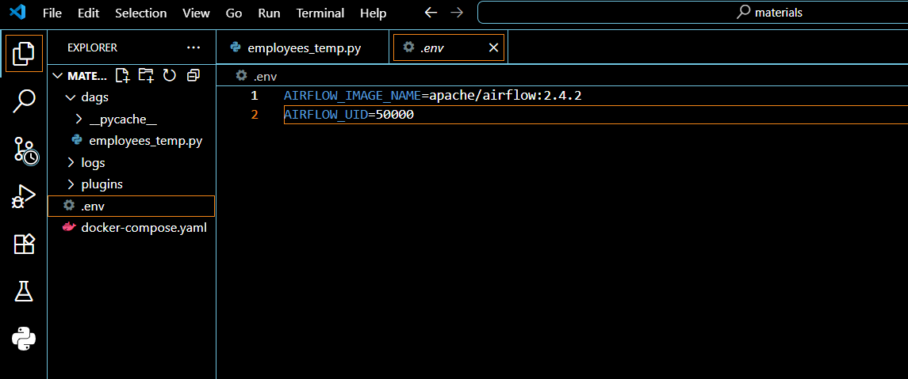

Run Docker Compose
- In the terminal (command prompt), I executed the command:
docker-compose up airflow-init
docker-compose up
This started the Airflow services (scheduler, webserver, postgres, etc.).
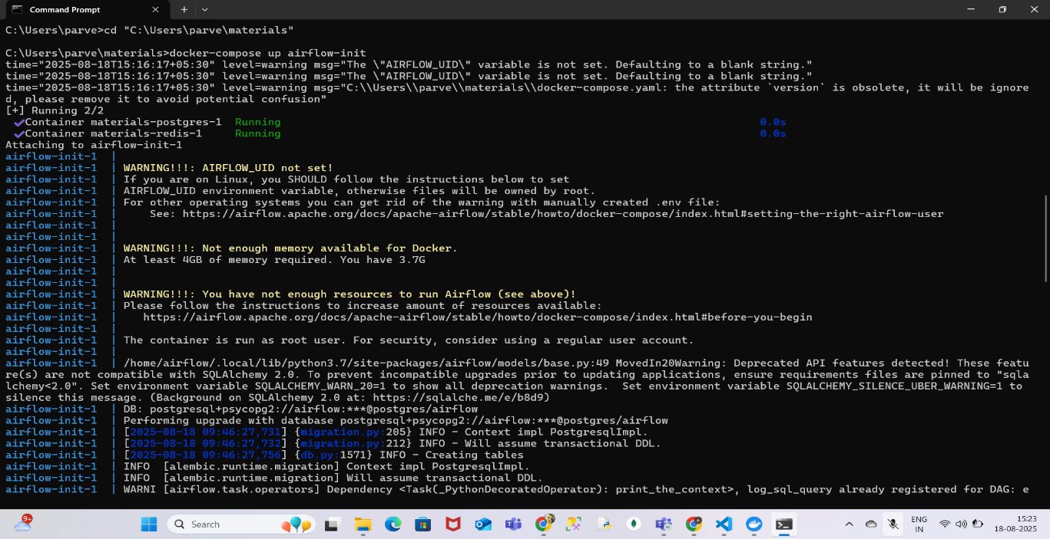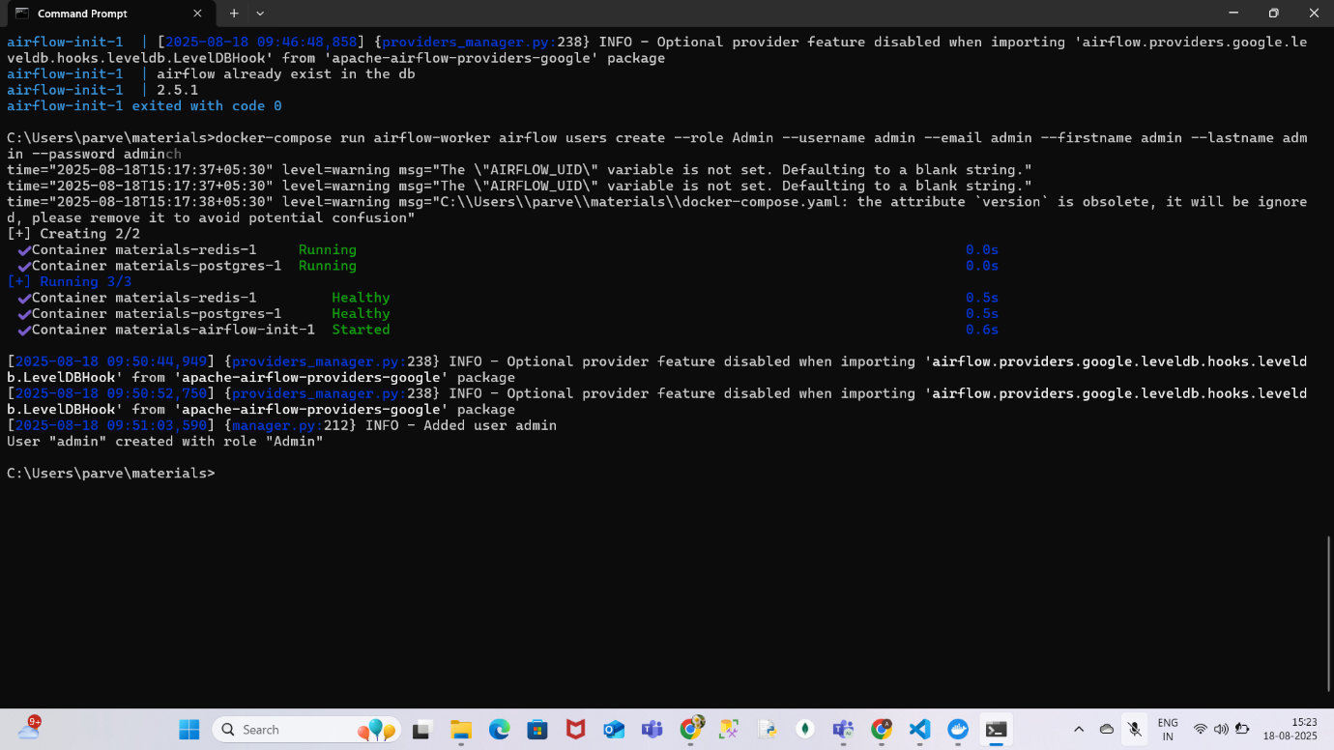
Access Airflow Web UI
- Opened the browser at http://localhost:8080.
- Logged in using:
    - Username: admin
    - Password: admin
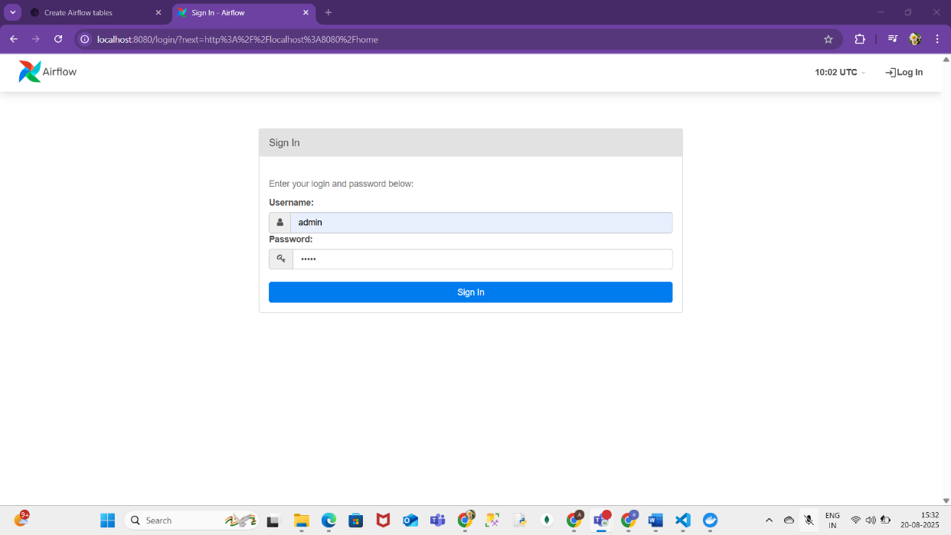
Creating a Connection
- Navigated to Admin → Connections in the Airflow UI.
- Clicked + Add Connection and filled the details:
  - Connection ID: tutorial_pg_conn
  - Connection Type: Postgres
  - Host: postgres
  - Database: airflow
  - Login: airflow
  - Password: airflow
  - Port: 5432
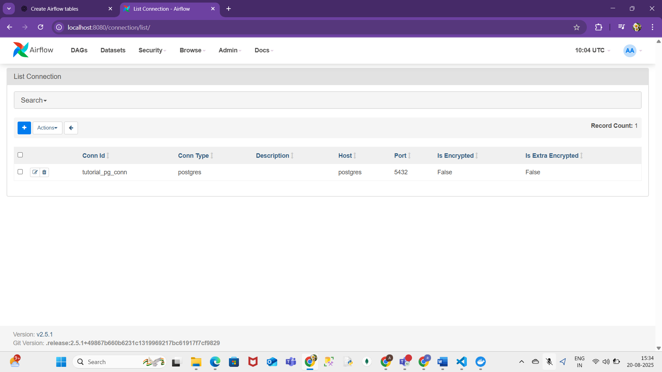
DAGs in Airflow
- Definition:
A DAG (Directed Acyclic Graph) is a collection of tasks with defined dependencies. In Airflow, DAGs are written in Python and describe the workflow structure.
- Creating a DAG File:
  - Inside the dags/ folder in VS Code, I created a Python file, for example employees_temp.py.
  - In this file, I defined tasks for creating staging and final tables in Postgres.
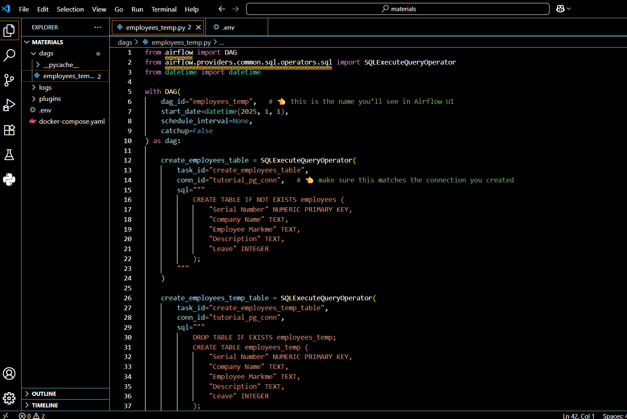
- Running the DAG:
  - After saving the DAG file, I refreshed Airflow UI.
  - The DAG appeared in the DAGs list.
  - I unpaused it (enabled it) and clicked Trigger DAG.
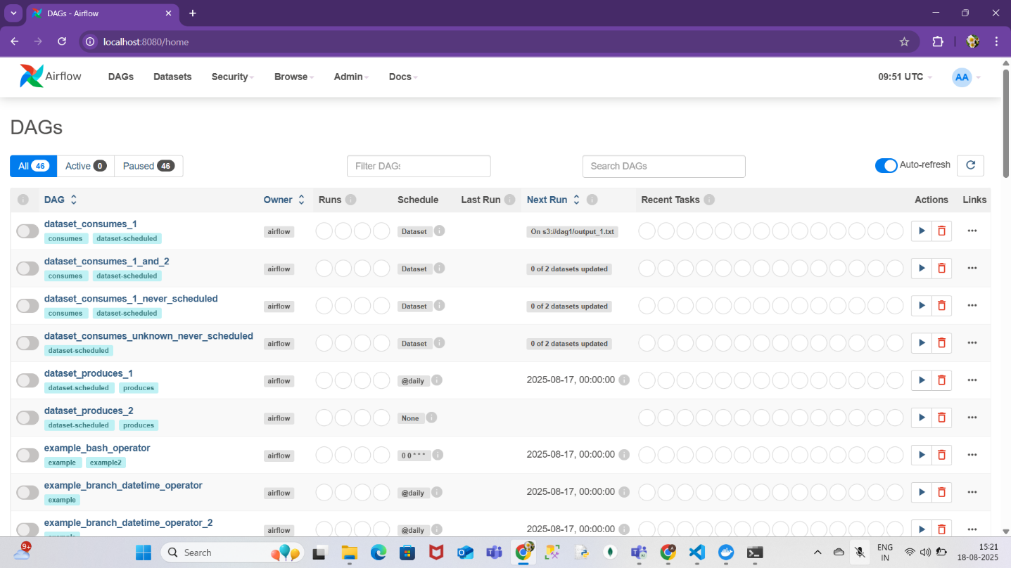
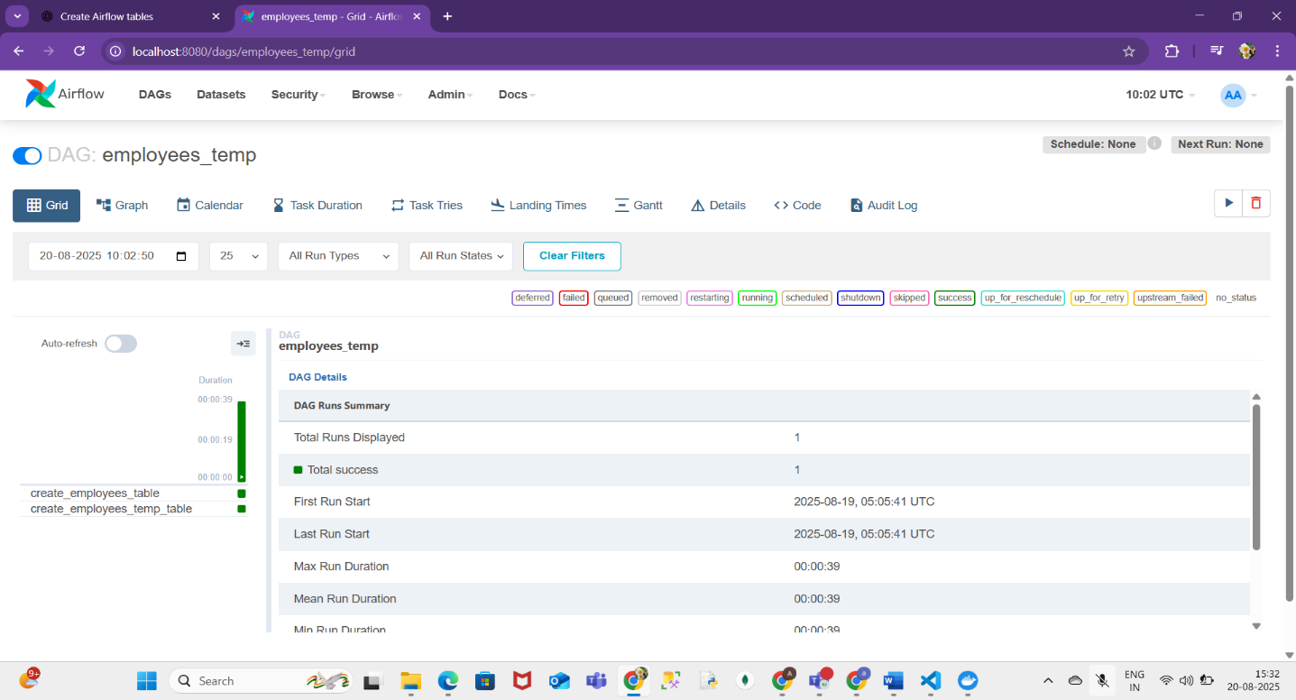
DAG Views
- Graph View → Shows tasks in a flow (arrows indicate dependencies).
- Tree View → Shows runs of the DAG in a timeline.
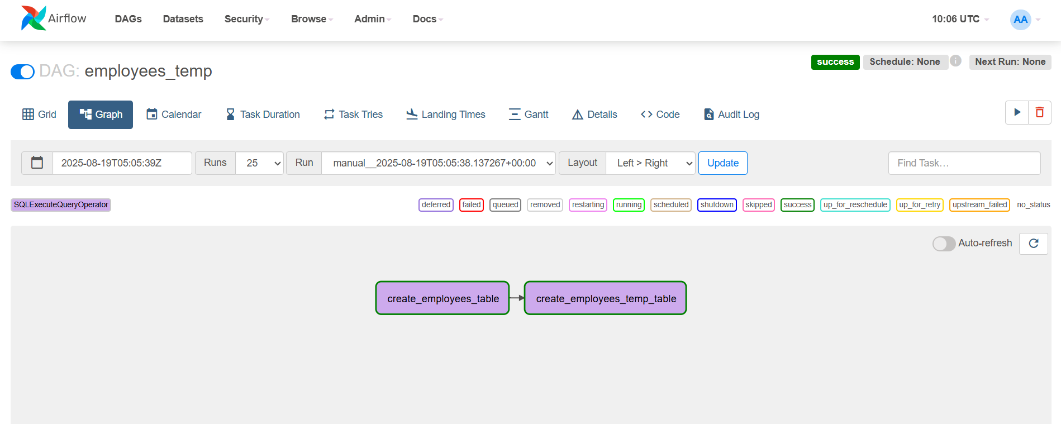

Conclusion
Apache Airflow makes it easy to manage data pipelines by combining code-based workflows with powerful scheduling and monitoring features. Using Docker Compose for setup, creating connections, and writing DAGs in Python, we can orchestrate complex workflows reliably and efficiently.

